The Rugby Colony: Oasis in Tennessee
“In one word, our aim and hope are to plant on these highlands a community of gentlemen and ladies; not that artificial class which goes by those grand names, both in Europe and here, the joint product of feudalism and wealth, but in a society In which the humblest members, who live by the labour of their own hands, will be of such strain and culture that they will be able to meet princes in the gate, without embarrassment and without self-assertion, should any such strange person ever present themselves before the gate tower of Rugby in the New World.”
Thomas Hughes's words on the opening day of his visionary community reflect his dreams for the young men populating his Rugby in the New World. Invoking Biblical imagery of American utopian rhetoric, he referred to his colony as a “New Jerusalem,” as John Winthrop once referred to his Massachusetts Bay Colony in 1630. Hughes devised the plan for the Rugby Colony, settled as an oasis in the woods on the Cumberland Plateau in Northeastern Tennessee. Influenced greatly by Ralph Waldo Emerson, Hughes felt that working the land was an honorable pursuit for educated men. In an address to the public school children at the Rugby School in England--for which his colony is named--Hughes told the adolescents, “For those who find after leaving school that they have no such outlook (for “honest” work) in England, I undoubtedly believe that they can't do better than go back to the land.” Hughes founded Rugby to create an “honorable” alternative for sons of aristocratic English families in the United States.
His dream only survived for eight years as the economic and cultural background of the residents of Rugby ultimately contributed to its demise in 1888. The young men and women who would populate this rustic village came from a world filled with servants, lawn tennis, and the theater, contrasting greatly with the rural people who grew up on the Cumberland Plateau. Rugbeians' aristocratic experiences in England permeated every aspect of their new life in America where they attempted to replicate the urbane lifestyle they understood. Rugby's elite class of settlers, who distinguished themselves from their neighbors, prevented the community from succeeding. Rugby's architecture, their propensity for leisure and subsequent failure of economic endeavors, and their perceptions of the native Tennesseeans magnify the differences in class between the colony and its neighbors. The evidence, reflected in the genteel nature of Rugby’s upper-class residents, ultimately prevented the colony from ever succeeding in the rural hills of Tennessee.

British Roots in an American Forest
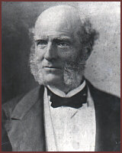
What brought Hughes's attention to the plight of previously privileged sons? Much of Hughes's work in England focused around education and reforming the school system. In the late-eighteenth and early-nineteenth centuries, each British secondary school and university only accepted members of the Anglican church, refusing admission of children from different religious backgrounds. By the mid-nineteenth century, reformers attempted to remedy the problem and open the public school doors to a more diverse cross-section of boys. Thomas Arnold implemented this practice, along with educational reform at his Rugby School. Thomas Hughes was a pupil of Arnold who wanted to continue the implementation of change, initiated at Rugby, at other schools. Through his experiences at Rugby, Hughes felt he could sow seeds of reform in his novel, Tom Brown's Schooldays in 1857. The success of his novel brought him increased notoriety in the United States, since Hughes was already known in the north for speaking out against slavery before and throughout the Civil War.
Hughes was not only active writing, but served as a politician and reformer. He founded The Working Men's College in London and attempted to break down class barriers at Oxford University, his alma mater. Hughes also served as a Liberal member of Parliament, a judge, and Queen's Counselor. He also worked in the Cooperative and Christian-Socialist movement, establishing labor associations and cooperatives. Despite his efforts to dissolve barriers for the working class in labor and education, the primogeniture system of the British gentry bothered him immensely. He viewed it as the last remaining vestige of the Middle Ages. This practice gave the oldest son of wealthy families the entire inheritance—land, money, and valuables. This left younger sons without land and few “respectable” options:
- to study medicine
- to study law
- to join the clergy.
Many of these younger sons attended the public schools, where Hughes observed their plight. Hughes set out to remedy this problem and searched for a suitable settlement for these young, genteel, educated men.
He visited the United States in 1870 and received a hero's welcoming that would not mirror the reception in Eastern Tennessee. Many dignitaries, including the Secretary of State Hamilton Fish, Charles Sumner, Ralph Waldo Emerson, Henry Wadsworth Longfellow, and others, received him as their guest. He toured the United States, making numerous contacts, who later would assist him in finding land for his settlement. A group of Bostonians who were searching for unoccupied farm lands to promote migration from the crowded Northeast, notified him of good land in Northeast Tennessee. Hughes then gathered investors and took over the project in 1879. He initiated an Anglo-American coalition and formed the Board of Aid to Land Ownership. By June of the next year, the organization purchased 50,000 acres to resell to Rugby colonists. A settler needed to put down one-third the price of a lot and then paid off the rest within two years. This system stopped the cycle of primogeniture, allowing aristocratic sons to own land. Despite the original organization's international composition, the majority of settlers were British.
From the beginning, although nestled in America, the settlement at Rugby, Tennessee retained a high level of elitism projected by the British residing there, especially evident in the physical plant of the colony. October 5, 1880 was the official opening day of the Rugby Colony and at that time the Tabard Inn, three boarding houses, the commissary, and some private homes already stood on the site. The name of the inn, the “Tabard,” borrowed its title from the Southwark Tabard Inn, the gathering place in The Canterbury Tales. This small gesture reflected the omnipresent British heritage of the colony. Even the name of the colony, “Rugby,” harkened back to Hughes's days at the Rugby school in England.
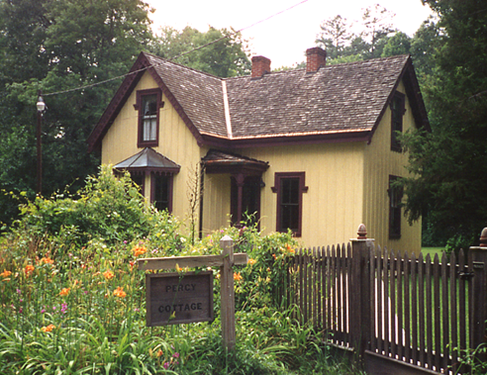
The architectural planning of the colony reflected the high class of the people settling in the hills of Tennessee, because of their knowledge of popular architectural styles of the late nineteenth century. The edifices were built in what Alan Gowans terms the “Picturesque” styles, prominent throughout the Victorian era in both England and in the United States. The Picturesque style flourished in urban areas in the late nineteenth century and served the social function of promoting American ideals and legitimized wealth as democratic. These styles were so decorative and intricate—contrasting with Classicism—that Gowans argues, regardless of an observer's knowledge of past styles, she or he could enjoy a building's aesthetics. While emulating past European styles, the Picturesque building became very popular in the United States. However, for the Rugbeians, the architecture reminded them of the British landscape, the heritage from which the new styles drew upon. Examples can be seen in various edifices in the plan of the town.
The plan of the Rugby town imitates the plan of an English Village. The placement of certain buildings makes the town the center of the colony's life, while individual plots of farm land lie extraneous to the small area cleared for the town center. The hamlet includes the church, school, hotel, and library, and it also became the site for the colony's many leisure activities. The winding paths and roads situated within the forest, adhere to the contour of the terrain and follow with the Picturesque motif. Town planners reserved strips of land near the streams as public parks and always kept the area well-groomed with various floras of the surroundings. Planning that followed natural boundaries differed greatly from the rectal-linear planning of most towns in the American territory west of the Appalachians.
The Board of Aid to Land Ownership, Hughes company, hired architects to design the buildings and plan a village. Cornelius Onderdock arrived to supervise the construction of the public buildings in the Rugby town. All of the buildings were supposed to be “attractive and roomy,” while their names were distinctively British, such as the Tabard Inn, or Kingstone Lisle, Thomas Hughes's home.
For many of the communities we have studied this year, including the Shakers, the Oneidans, and the LLano del Rio settlement, architectural planning has been an integral part of the community's philosophy. However, the Rugby Colony did not profess a new social order, religious revelation, or technological innovations through their architecture. The designs merely reflected residents' desire to emulate contemporary stylistic trends of the 1880's, present both in England and in the United States. These stylistic trends required one-family occupancy of homes, in contrast with other utopian settlements that emphasized community by constructing multi-family residences. Even though Rugbeians believed themselves to be pioneers, they designed the town’s social space and homes to support the lifestyle they knew in England.
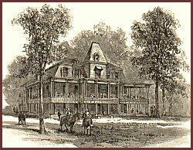
A good example of the Victorian styles is the first Tabard Inn completed in 1880. Donning a mansard roof with dormer windows and columned verandah with patterned railings, the Inn is a good example of the French Second Empire style. The physical setting of the hotel, amongst trees and landscaped paths, helps to create its Picturesque style by the intermingling of architecture with nature. Just as American architect Andrew Jackson Downing promoted nestling residential homes amongst landscaped pieces of land, the Inn was nestled in nature. The large, two-story, wrap-around verandahs allowed guests to enjoy the clean air and to relax and take in the magnificent views of the Plateau area. The Inn was a site for socializing and the verandahs, as an extension of the Inn into nature, were gathering places for guests and residents. The wealth symbolized by the Tabard Inn could also be found in many of the residences in town.
Most of the colony's homes were built in various Victorian styles, including the Queen Anne's and Stick Styles. Asymmetrical by design, many carried porches with decorative columns, important for socializing and for escaping the summer's heat, as well as different sloped pitches in the roof lines. Some, like Thomas Hughes's home, Kingstone Lisle built in 1884, carried decorated verge boards on the dormer window roofs, providing extra detailing to a relatively simple Queen Anne style home. Another feature of the Picturesque style is a polychromatic texture on all facades, which many of the homes exhibited. The intricacies of the private homes at Rugby differed greatly from the homes of the native Tennesseeans.
A vernacular house of the plateau contrasted with the architecture of Rugby by its simplicity. Built for function primarily, rather than style, the mountain cabins consisted of a simple one or one and a half floored structure with unfinished, timber cladding. It is less finished and refined than Hughes's Kingstone Lisle. His two story painted home appears much more decorative than a typical cabin of local residents. The mere fact that there existed a pre-meditated town distinguished the settlement from anything in the area. The Victorian architecture, even though it might be found in the lowlands of the state, set the Rugbeians apart from their neighbors and labeled them as outsiders.
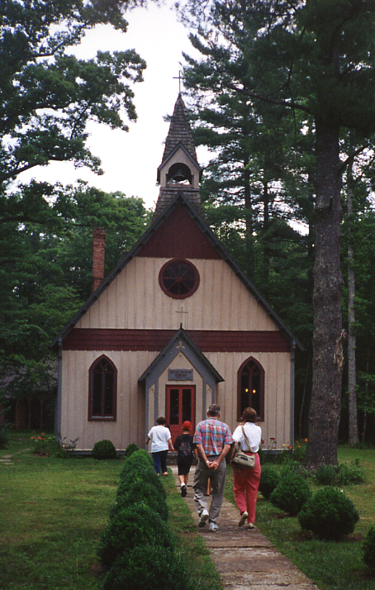
Even the Christ Church, Rugby's Episcopal Church, reflected the Picturesque style in Gothic Vernacular. The pointed arch and detailed stained glass windows mark the Church as Gothic, but its short steeple and cladding in wood denote it as a mixture of styles. This building's mixed styles allow it to blend in with the Picturesque styles of the rest of the village, while retaining the feel of an Anglican Church of England.
These styles of Rugby might be found in the lowlands in cities such as Knoxville or Chattanooga, because they were common in urban areas, but it would be unusual to discover them in the rural mountains. The region was sparsely populated and much more rural than the lowlands. Knoxville, the closest urban area to Rugby, is seventy-five miles away and only was accessible, at that time, by one crude road on horseback or by ox cart. Within a twenty-five mile radius of this settlement, there were only three towns populated with over one hundred people. Gowans described this style as prevalent in urban areas as a means to legitimize wealth in America. In contrast, these hills did not showcase monetary abundance, so there was no need for this style of architecture. As a result, Rugby's buildings differed greatly from the few existing farm houses in the area.
The British settlers at Rugby, already wealthy, tried to legitimized their existence through the colony, and their architecture assisted them with that goal. Rugby does not usually come to mind when thinking of symbols from the Tennessee hills, rather, images of Daniel Boone, Davey Crocket, or Andrew Jackson. This quaint, English village promoted the wealth of its own and maintained its upper class status in the woods of Tennessee, while neglecting to build a thriving community with longevity.

Thomas Hughes, Rugby, Tennessee: The American Utopian Adventure (1881; reprint Philadelphia: Porcupine Press, 1975), 106.
Hughes, Rugby, Tennessee, 47; 24-5; 135.
Brian Stagg, The Distant Eden:Tennessee's Rugby Colony (n.p.: Paylor Publications, 1975), 1.
W.H.G. Armytage, "Public School Paradise," Queens' Quarterly 57 (Winter 1950-51): 530.
Stagg, A Distant Eden, 2-3.
Ibid., 3.
"The English Gardens at Rugby," Harper's Weekly 24 (Oct. 16, 1880): 665.
Armytage, "Public School Paradise," 531-2.
Alan Gowans, Styles and Types of North American Architecture: Social Function and Cultural Expression (New York: HaperCollins, 1992), 165-207. Subsequent architectural terminology follows Gowans's definitions.
Sarah L. Walton, Memories of Rugby Colony (n.p., n.d.), 6.
Gowans, Styles and Types of North American Architecture, 153-4.
James Patrick, Architecture in Tennessee, 1768-1897 (Knoxville, TN: University of Tennessee Press, 1981), 183-203.
Walton, Memories of Rugby Colony, 3; William Bruce Wheeler and Michael J. MacDonald, "The Communities of Eastern Tennessee, 1850-1940: An Interpretive Overview," East Tennessee Historical Society's Publications, nos.58-59 (1986-7): 17-19.
Ernest I. Miller, The English Settlement at Rugby, Tennessee, Rural Research Series, Monograph No. 128 (Knoxville, Tennessee: University of Tennessee, 1941), 31.

